1. 
2. 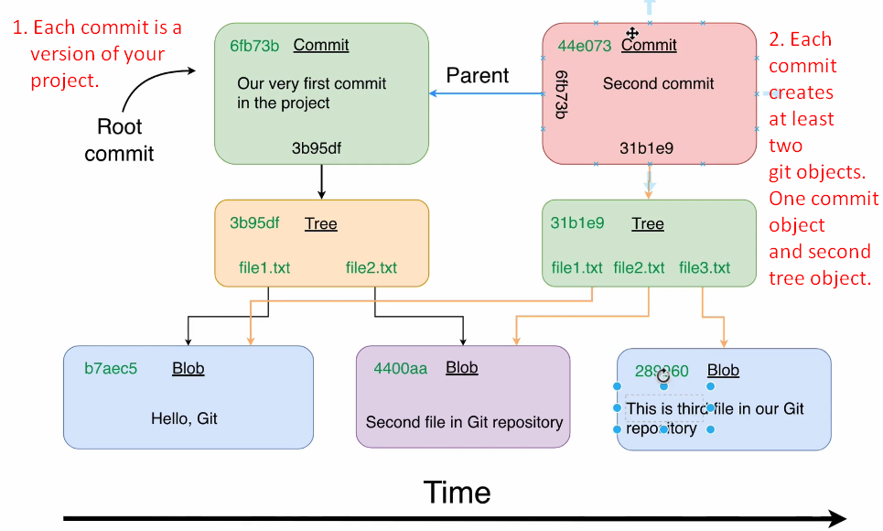
3. **Next Lec**:
   1. Installing Github Desktop.